**✅ What Is React?**

React is a **JavaScript library** for building **user interfaces (UIs)** — basically, it's used to create websites that change without reloading the page.

Example: Facebook, Instagram, Netflix use React. When you like a post or see new comments **without the page refreshing**, that’s React at work!

## React Basics We’ll Cover First

1. What is React and how to start
2. Creating a React App
3. JSX (React's HTML + JS syntax)
4. Components (like building blocks)
5. Props (like passing data into blocks)
6. State (for changing data inside the component)
7. Event Handling (like button clicks)
8. Styling in React (inline, class-based)
9. Hooks (useState, useEffect – start small)

* **What is JSX?**

**JSX** stands for **JavaScript XML**. It lets you write **HTML inside JavaScript**.

Example:

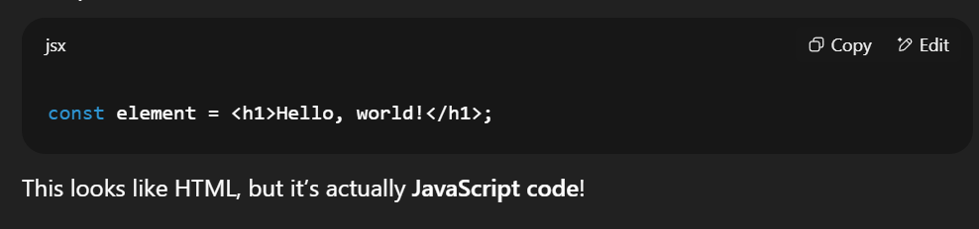

## Why Use JSX?

* It’s easier to create UI elements
* Looks like HTML, so it's familiar
* React uses JSX to describe what should appear on the screen
* **PRACTICAL: Let’s Use JSX in App.js**

**🔹 Step-by-Step:**

1. Open your React project (my-first-app)
2. Go to: src/App.js
3. Replace everything with this:

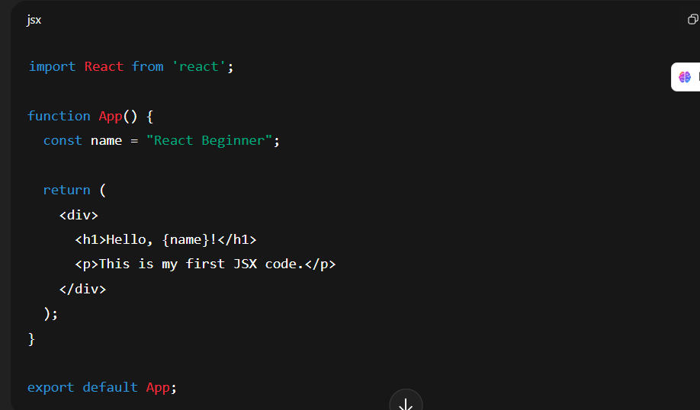

**Explanation:**

* const name = "React Beginner"; → A JS variable
* {name} → Used inside JSX to display value
* Everything inside <div> is JSX (like HTML)

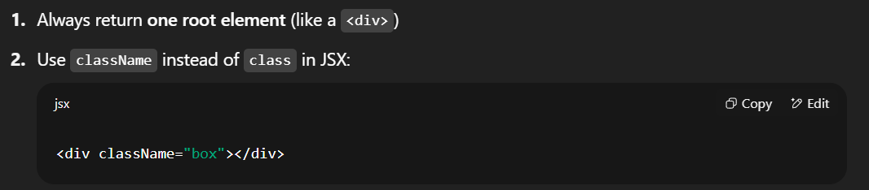

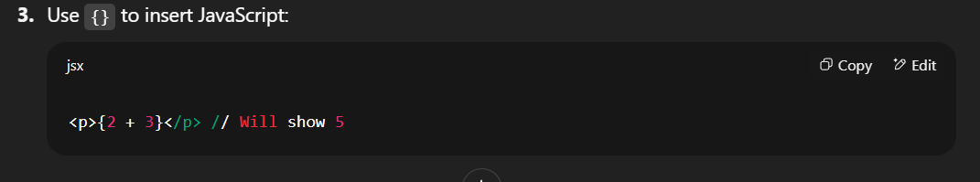

* **What is a Component?**

A **component** is like a **mini app** or **reusable block** of code.

Just like in LEGO — each block is small, but together they build something big.

* **Why Use Components?**
* Reuse code (e.g., Button, Card, Navbar)
* Organize your UI
* Make large apps manageable
* **Types of Components**

1. **Functional Component** ✅ (this is what we use now)
2. Class Component (older, not needed for now)

We’ll stick with **Functional Components**, using simple functions.

## 🎯 Step 4: Props — Passing Data to Components

### 🧠What Are Props?

Think of **props** as:

🎁 "Properties" or "Packages of Data" you send into a component.

Example:

If App is a parent, and WelcomeMessage is a child, App can send a message to WelcomeMessage using props — like a parent giving a child a note.

### **Real-Life Analogy**

Imagine you're a restaurant waiter:

* You (the parent component) give a **menu item** (prop) to the **chef** (child component)
* The chef uses that item (prop) to make the dish (output)

## ✅ What is the ****Need**** for Props?

### 🚗 Imagine This:

You build a car component called <Car />.  
Without props, every car looks the same:

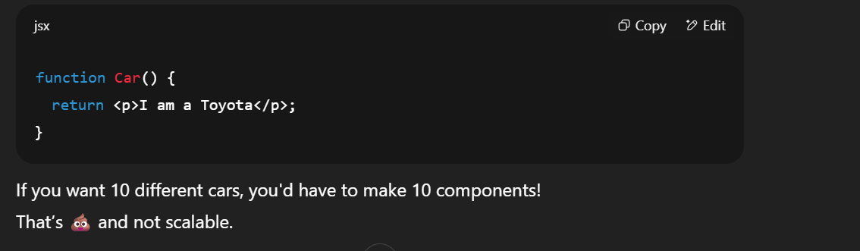

### **🧠 PROBLEM Without Props:**

* Repeating same component many times with different content = code duplication ❌
* Can’t reuse components for different data ❌
* Not dynamic ❌

### **✅ Props SOLVE THIS!**

* Props let us create **one reusable component**, and give it **custom content**.

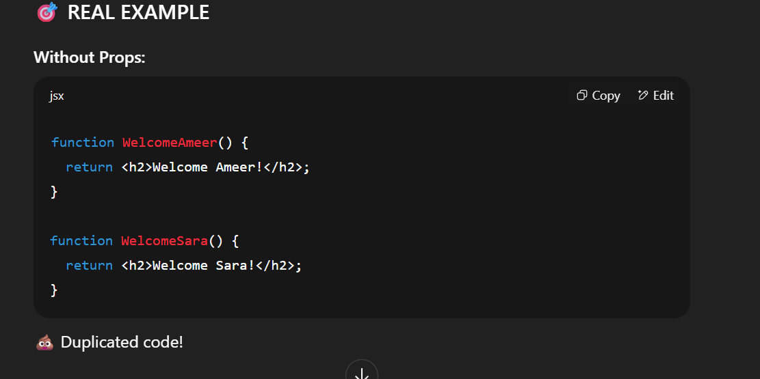

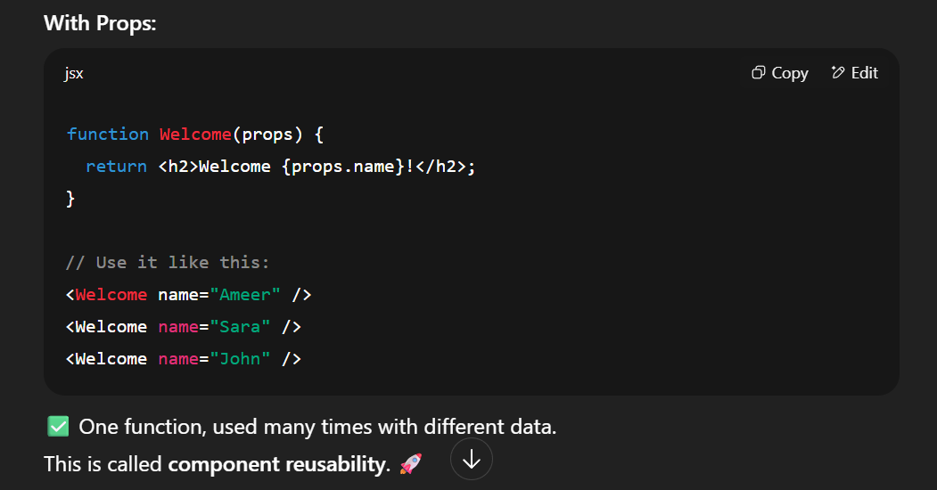

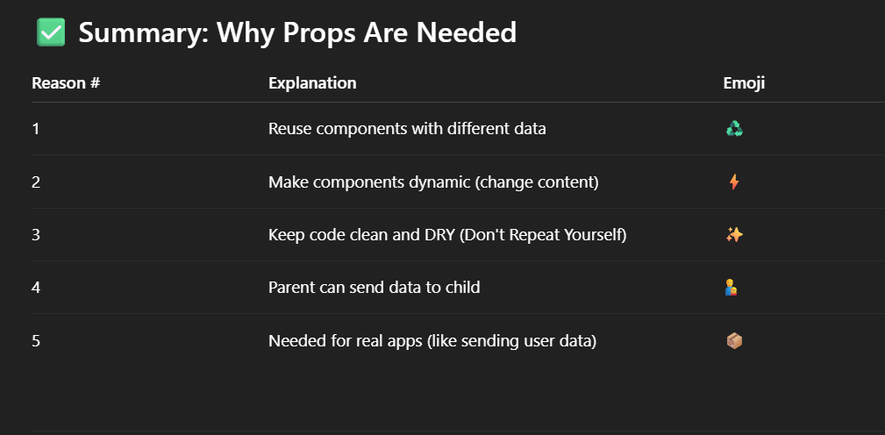

✅ **Step 5: useState — React State**

## 🧠 What is useState?

React is great at building **dynamic** UIs.  
But to make something **change**, like:

* A button that increases a counter 🧮
* A form input that stores text 📝
* A toggle that shows/hides something 👁️

You need a way to **store and update values** inside a component.

That’s what **useState** is for:  
👉 It lets your component **remember** things, and **react** when they change.

## 🧒 Simple Way to Understand:

Imagine useState as a box 📦 with a value inside.  
You can open it (read it), and change it — and when you do, React **re-renders** the component to show the new value.

